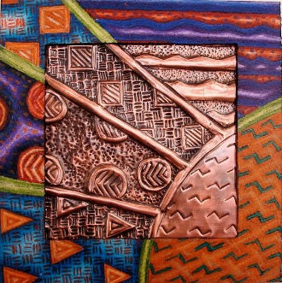
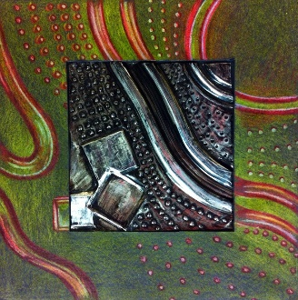
Repousse’ Elemental Tile Project
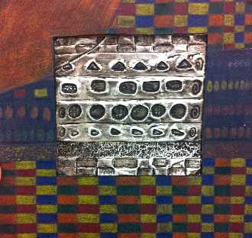

Project Objectives:
- Student will create a low relief image in metal (copper foil) using the process of Repousse’
- Student will be able to determine the difference between organic and geometric shapes
- Students will create a design that will be rendered on both a 2D surface and a 3D surface
Repousse- shaped or ornamented with patterns in relief made by hammering or pressing on the reverse side
Copper Respousse Rubric | Student Evaluation  (Circle one) | Teacher Evaluation
Meets Requirements:
- Design has 3 organic and 3 geometric examples
- Design uses line, pattern and contrast effectively
- Design has been successfully continued to black border
Level of effort/attitude:
- Worked hard every class and did not clean up early
- Focused on work and good craftsmanship and used tools/materials correctly
- Project is complete and turned in on time.
Craftsmanship:
- Evidence of hard work and quality of skill apparent
- Artwork has a variety of high and low points
- Design on outer paper is neat and drawn well
Final Teacher Evaluation Final Grade: /100 pts

