PIN UP ART SHOW
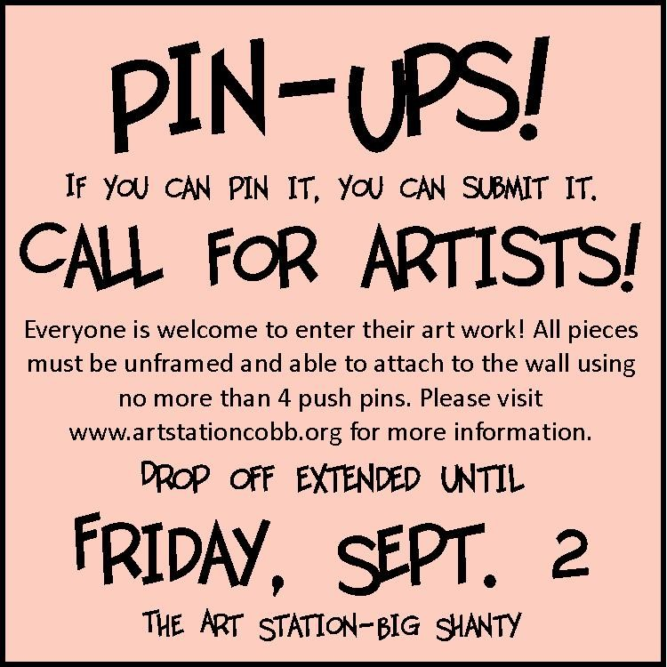

Yes I give my child (child’s name)

_________________________________________________, permission to enter and exhibit artwork in the PIN UP art show at the Big Shanty Art Station in Kennesaw.
Parents Name:
__________________________________________________
Parents email: __________________________________________________
Date: ______/________/2016

