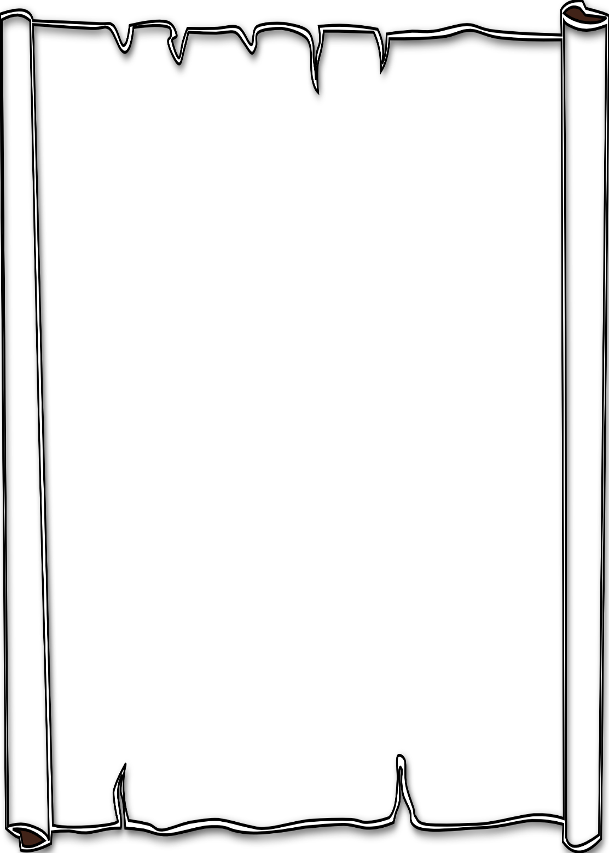

**When:** Tuesday, October 11th   
 6:00 pm – 7:00 pm

*Snacks and refreshments provided *

**Where:** Durham Middle School Art Room - 2891 Mars Hill Rd. Acworth

You are invited to come read and view the narratives your student has written/or illustrated as a collaboration project between Durham Middle School Artists and Lost Mountain Middle School Authors.

We hope to see you there!

Mrs. Gaut & Mrs. Downs

**Gallery Walk**

**Gallery Walk**

**When:** Tuesday, October 11th   
 6:00 pm – 7:00 pm

*Snacks and refreshments provided *

**Where:** Durham Middle School Art Room - 2891 Mars Hill Rd. Acworth

You are invited to come read and view the narratives your student has written/or illustrated as a collaboration project between Durham Middle School Artists and Lost Mountain Middle School Authors.

We hope to see you there!

Mrs. Gaut & Mrs. Downs