Characteristics and Organization of Life

Title: Foil Face Mask Making

Stage 1: Desired Results
Understandings
Students will understand . . .
- The difference between relief sculpture and sculpture-in-the-round
- How to create a mold and construct the mold into a 3D mask
- That mask making and design is a career path in visual arts
Essential Questions | Knowledge & Skill/Standards
How will you create an aesthetically pleasing sculptural relief mask, using your knowledge of the elements of art and principles of design?  What is the difference between relief sculpture and sculpture-in-the-round? | VA8PR4 Keeps a visual/verbal sketchbook journal consistently throughout the course, to collect, develop, and preserve ideas in order to produce works of art  VA8PR5 Develops and maintains a portfolio of artworks  VA8MC1 Engages in creative process to generate visualize ideas  VA8AR3 Plans and presents appropriate exhibition for works of art  What do I want students to know?  - How to create a relief sculpture (mask)  - The difference between a relief sculpture and sculpture-in-the-round  - Mask making and design is an art career  What do I want students to be able to do?  - Make a mask using foil and paper mache
Stage 2: Assessment Plan
product, portfolio, preliminary sketch, class discussions
Performance Task Summary | Other Evidence, Summarized
Students will create and design a 3D mask using their knowledge of the elements of art and principles of design. | Phase 1.)  https://www.youtube.com/watch?v=Dxm4S_2WwI4#t=573.211001  Phase 2.)  https://www.youtube.com/watch?v=41tVWPLJwpQ
Self-Assessments | Rubric Titles
- Observational Checklists  - Class discussion  - Student Reflection  - Exit questions | - Student Reflection  - Self-assessment (rubric)  - Peer-assessment (verbal)
Stage 3: Learning Activities
Vocabulary:

What is the difference between relief sculpture and sculpture-in-the-round?
A relief sculpture is a type of sculpture in which a design projects from the surface of the sculpted material, like a rubber stamp, though not necessarily flat. Relief sculpture can be seen from only one vantage point, usually straight on. Sculpture-in-the-round is freestanding and finished on all sides. A viewer can move all the way around a sculpture-in-the round, and is able to look at the work from multiple vantage points.

Day1)
Activator: Students will watch a you tube demonstration on making a face mold out of foil
Instruction: Teacher will go over lesson expectations and criteria.
Students will begin to make their own mold
Summarizer: Add name to mask with sharpie, clean-up (save extra foil for tomorrow)

Day 2) Activator:

What is the difference between relief sculpture and sculpture-in-the-round?
Instruction: Review steps to making a foil face mold
Students will continue to create their mold, adding and addition pieces with the
extra foil
Summarizer: Is your mask a relief sculpture or sculpture-in-the-round?

Day 3) Activator: Watch a demonstration on paper mache on You Tube
Instruction: Students will paper mache their foil face mold
Summarizer: Clean-up

Day 4) Activator: Sketchbook drawing
Instruction: Come up with at least one mask design in sketchbook and choose a
Color scheme for mask and any other materials you plan to use the make your piece
Complete
Summarizer: Title your piece

Day 5) Activator: Sketchbook drawing
Instruction: Sand down your mask, paint a layer of white on mask
Summarizer: Share your design with a peer

Day 6,7,8
Activator: Sketchbook assignment
Instruction: Draw, paint, add mixed media to mask
Summarizer: Clean-up, reflect on work, title, date, sign work
End of day 8) Turn work in

Differentiation:  GEN ED:  Draw at least 1 preliminary sketch for mask design, choose a color scheme for paint, use extra foil to make at least one other piece to your mask whether its ears or eye brows | SPED:  1 prelimianry sketch for mask design, get assistance from teacher and peers, apply paint in solid color (no value), use larger paint brush and tools, mask must have eyes, nose, lips | Gifted:  Draw multiple prelimary designs, Be a peer helper,  Show value when applying paint, make a complex mask design, Mixed Media technique,  “think outside the box”, use extra foil to create ears, hair, bow, other accessories and body parts

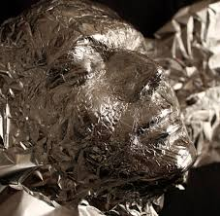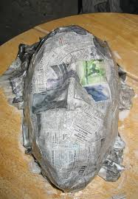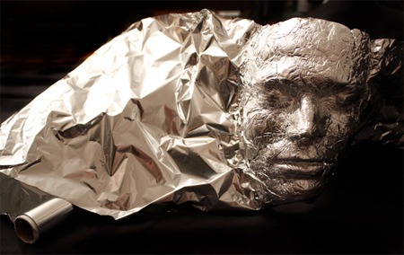

Foil Mold Mask Making

- Watch You Tube Instruction on foil molds
- Create a foil face mold
- Paper mache your mold
- Draw at least one mask design in sketchbook
- Choose a color scheme for applying paint
- Sand make down for a smooth texture
- Base coat mask with white paint
- Draw design on mask
- Paint mask (show value)
- Add mixed media
- Title, date, sign
- Turn work in
Instruction:

Student Name:  Lesson: Foil Mold Mask Making |  |  | Class Period:
Circle the number that best shows how well you feel that you completed that criterion for the assignment. |  | Excellent | Good | Average |  | Needs Improvement
Criteria 1 – Product/composition: 3D relief mask made from a foil mold and paper mache |  | 20 | 19 – 18 | 17-15 |  | 14 or less
Criteria 2 – Preliminary sketches and design: drew at least one design to place on mask, wrote title in sketchbook, selected a color scheme and any other media that would be applied |  | 20 | 19 – 18 | 17-15 |  | 14 or less
Criteria 3 – Color/Paint: Chose a color scheme, showed value, tints, and shades of color (ex: cool colors; light blue, dark blue, blue-green, green) |  | 20 | 19 – 18 | 17-15 |  | 14 or less
Criteria 4 – Effort: took time to develop idea & complete project? (Didn’t rush.) Good use of class time? |  | 20 | 19 – 18 | 17-15 |  | 14 or less
Criteria 5 – Craftsmanship – Neat, clean & complete? Skillful use of the art tools & media? |  | 20 | 19 – 18 | 17-15 |  | 14 or less
Total: 100  (possible points) | Grade: /100 = |  | Your Total |  | Teacher Total
