Name _________________________________________ Class ___________

Complementary Colored Animals | Excellent  20-19 pt.s | Good  18-15 pts | Average  14-10 | Needs Improvement  9-0
Drawing Technique:
You created a 2D observational animal drawing. Your drawing looks like the animal you have chosen as your reference. You have at least one animal portrayed.
Effort: took time to develop idea & complete project? (Didn’t rush.) Good use of class time?
Complementary Colors:
You have shown tints and shades of one set of complementary colors. Your animal is one color while the background is the other color.
Craftsmanship – Neat, clean & complete? Skillful use of the art tools & media?
Thumbnail Sketches/sketchbook activities:
Art vocabulary is written in sketchbook. You have created preliminary sketches of your chosen animal.
Total:
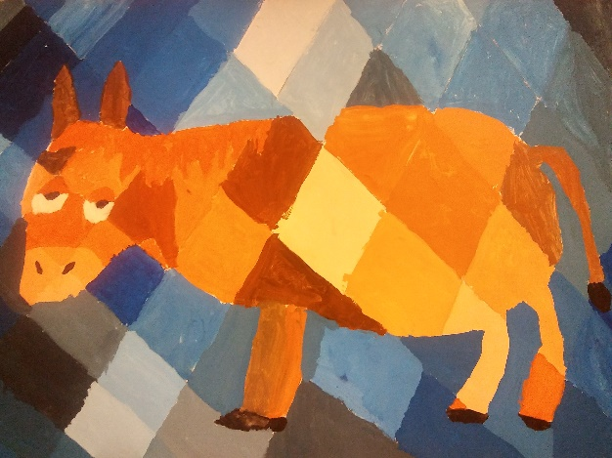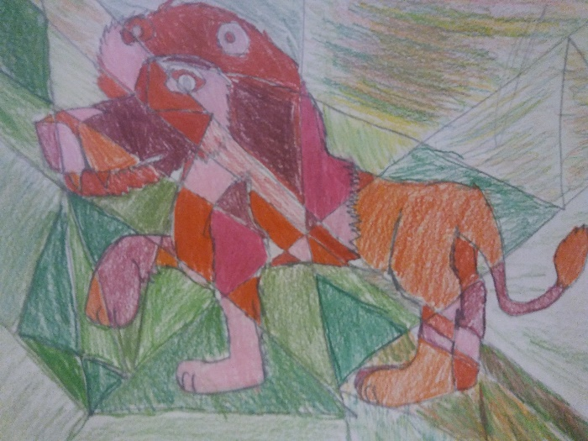
(Above) paint (Above) colored pencil

