My Surreal World

Student Name:

Lesson: Surreal World
Circle the number in pencil that best shows how well you feel that you completed that criterion for the assignment. |  | Excellent | Good | Average | Needs Improvement
Criteria 1 – Project Requirements: Creates a complete world/idea. Student created an original piece that is “like a dream that the audience wants to interpret”? All images original, Idea is original. At least one hand is incorporated in piece. |  | 10 | 9 – 8 | 7 | 6 or less
Criteria 2 – Composition: Highly aesthetic and original. Purposeful use of composition, angles, lighting, color, and movement. Excellent use of art elements and principles of organization. |  | 10 | 9 – 8 | 7 | 6 or less
Criteria 3 – Preliminary Sketches: Student drew at least 4 different hand gestures. Student composed a surreal world sketch incorporating at least one realistic hand drawing |  | 10 | 9 – 8 | 7 | 6 or less
Criteria 4 – Effort: took time to develop idea & complete project? (Didn’t rush.) |  | 10 | 9 – 8 | 7 | 6 or less
Criteria 5 – Craftsmanship – Neat, clean & complete? Skillful use of the art tools & media? |  | 10 | 9 – 8 | 7 | 6 or less
Total: 50  /50 pts x 2= | Grade:  _____________
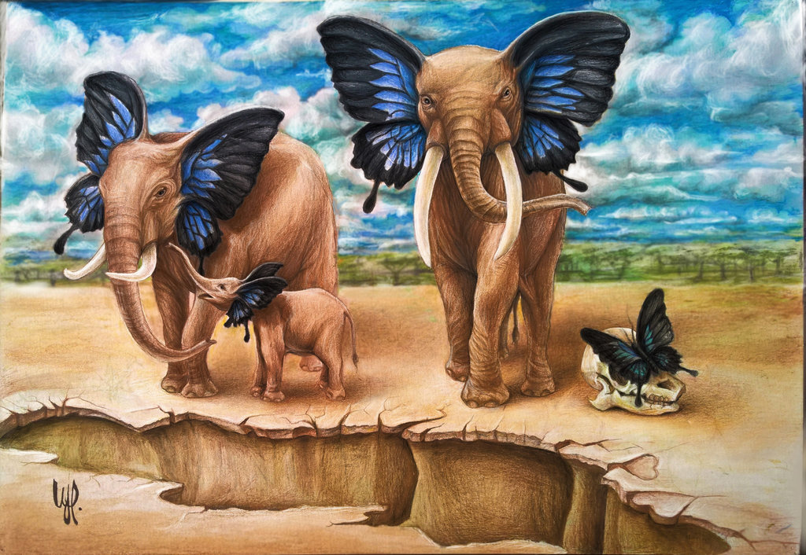
STEPS TO FOLLOW:
- First, you will draw at least 4 realistic hand gestures in your sketchbook
- Sketch a surreal world in your sketchbook
- Draw your final on 12x18 paper with pencil
- Make sure you fill page (space), draw off 4 edges of canvas, and overlap subject matter (objects in work)
- Incorporate at least one hand in your final
- Apply media neatly
- Show value, tints, and shades of color
- Title, date, and sign your work

