Would you like a sketchbook?
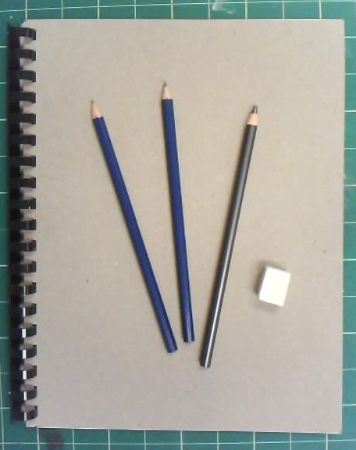
The Durham Visual Arts Department
Presents:

THE SKETCHBOOK SALE!

This is your opportunity to buy a good sketchbook at a reduced cost from the average art or supply store, and proceeds of the sales will go to support Durham Visual Arts Students!

We are offering one of two packages for sketchbooks:
Package A: Includes an 8 ½ x 11 inch sketchbook for $5.00.
Package B: Includes the 8 ½ x 11 inch sketchbook, 3 drawing pencils, and an eraser for $10.00

If you would like to order either of these packages, please fill out the form below and hand it in to Mrs. Gaut in room 711. Payment can be made in cash or check and placed in a payment envelope. These should be put into one of the secured black boxes in the school. Checks should be made out to Durham Middle School.

Student Name: ________________________________________Package A: _________Package B: ______________
(please check one)
Student Homeroom: ______________________________________________
*Sketchbook packages will be delivered to students 24-48 hours after receiving the payment.

Order forms should be turned in to Mrs. Gaut, Room 711.
Payment envelopes must be placed in a black lock box.

